SEMANTIC WEB

- What is Internet?

The Internet is a global system of interconnected computer networks that use the standard Internet Protocol Suite (TCP/IP) to serve billions of users worldwide.

- What is web/WWW?

Web is a network, an interconnected system of things or people. We are well known about the term www. The www is a system of interlinked hypertext document accessed via the internet.

- Problems with present web

  - Keyword-based search engines such as Yahoo and Google are the main
Tools for using today’s Web. However, there are serious problems associated with their use:
- High recall, low precision. Even if the main relevant pages are retrieved,
they are of little use if another 28,758 mildly relevant or irrelevant documents are also retrieved. Too much can easily become as bad as too little.
- Low or no recall. Often it happens that we don’t get any relevant answer
for our request, or that important and relevant pages are not retrieved. Although low recall is a less frequent problem with current search engines, it does occur.
- Results are highly sensitive to vocabulary. Often our initial keywords do
not get the results we want; in these cases the documents that we see contains different terminology from the original query.

  - Results are single Web pages. If we need information that is spread over
various documents, we must initiate several queries to collect the relevant
documents, and then we must manually extract the partial information
and put it together.
  - So it need human labors and become time consuming.

- What is Semantic web?

The Semantic Web is a web that is able to describe things in a way that computers can understand. The Semantic Web is a mesh of information linked up in such a way as to be easily processable by machines, on a global scale. You can think of it as being an efficient way of representing data on the World Wide Web, or as a globally linked database.
The Semantic Web is not about links between web pages.
Semantic web is an effort to enhance current web so that computers can process the information presented on WWW, interpret and connect it, to help humans to find required knowledge.
It is about language for recording how the data relates to real world objects. That allows a person, or a machine, to start off in one database, and then move through an unending set of databases which are connected not by wires but by being about the same thing. If a computer understands the semantics of a document, it doesn't just interpret the series of characters that make up that document: it understands the document's meaning.

- The aim of the Semantic Web:

Semantic web allow much more advanced knowledge management systems:
- Knowledge will be organized in conceptual spaces according to its meaning.
• Automated tools will support maintenance by checking for inconsistencies
and extracting new knowledge.
• Keyword-based search will be replaced by query answering: requested
knowledge will be retrieved, extracted, and presented in a human friendly
way.
• Query answering over several documents will be supported.
• Defining who may view certain parts of information (even parts of documents)will be possible

- Component of semantic web
Metadata:
In semantic web approach metadata or data about data is stored. That means it understand the meaning of the whole information. So when any user asks for any particular information it understand what the user is asking actually and provide the relevant information.

Ontology:
Ontology is an explicit and formal specification of conceptualization. Typically, ontology consists of a finite list of terms and the relationships between these terms. The relationships typically include hierarchies of classes. Ontology provides a shared understanding of a domain. Such a shared understanding is necessary to overcome differences in terminology.

Ontology is useful for the organization and navigation of Web sites.
Many Web sites today expose on the left-hand side of the page the top levels of a concept hierarchy of terms. The user may click on one of them to expand the subcategories.

Ontology is useful for improving the accuracy of Web searches.
The search engines can look for pages that refer to a precise concept in ontology instead of collecting all pages in which certain, generally ambiguous, keywords occur. In this way, differences in terminology between Web pages and the queries can be overcome.

Logic & Inference:
Provide formal languages for expressing knowledge.

An important advantage of logic is that it can provide explanations for conclusions:
the series of inference steps can be retraced.
prof(X) → faculty(X)
faculty(X) → staff(X)
prof(michael)
Then we can deduce the following:
faculty(michael)
staff(michael)
prof(X) → staff(X)

It is used by intelligent agent for making decision and selecting course of action. For logic to be useful on the web it must be usable in conjunction with other data and it must be machine processable as well.

Agent:
Agents are pieces of software that work autonomously and proactively.
A personal agent on the Semantic Web will receive some tasks
And preferences from the person, seek information from Web sources, communicate with other agents, compare information about user requirements and preferences, select certain choices, and give answers to the user.

- Architecture of Semantic Web

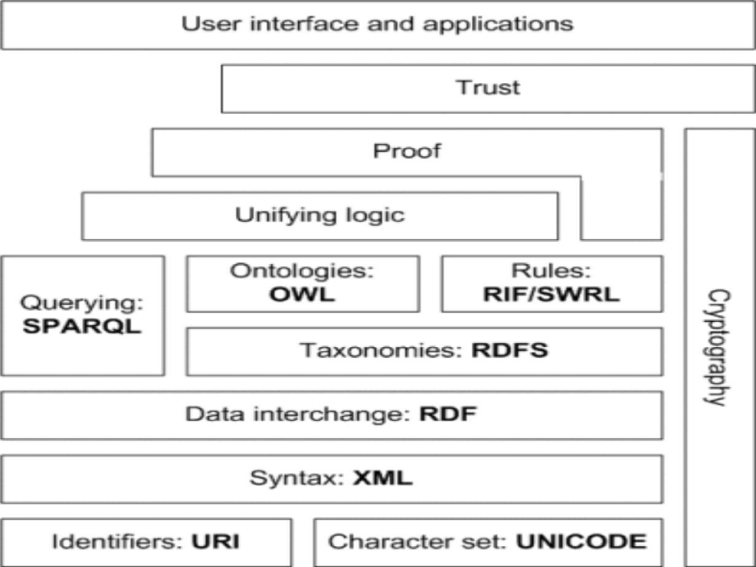
The architecture of semantic web is illustrated in the figure above. The first layer, URI and Unicode, follows the important features of the existing WWW. Unicode is a standard of encoding international character sets and it allows that all human languages can be used (written and read) on the web using one standardized form.
A URI is simply a Web identifier, like the strings starting with http or ftp that you often see on the World Wide Web. Uniform Resource Identifier (URI) is a string of a standardized form that allows to uniquely identifying resources (e.g., documents).
A Uniform Resource Locator (URL) is a URI that, in addition to identifying a resource, provides network location.
Extensible Markup Language (XML) layer with XML namespace and XML schema definitions makes sure that there is a common syntax used in the semantic web. XML is a general purpose markup language for documents containing structured information. A XML document contains elements that can be nested and that may have attributes and content. XML namespaces allow specifying different markup vocabularies in one XML document. XML schema serves for expressing schema of a particular set of XML documents.
A core data representation format for semantic web is Resource Description Framework (RDF). RDF is a framework for representing information about resources in a graph form, where the node of the graph represent the resources and the edges represents the links. It was primarily intended for representing metadata about WWW resources, such as the title, author, and modification date of a Web page, but it can be used for storing any other data. It is based on triples subject-predicate-object that form graph of data. All data in the semantic web use RDF as the primary representation language.
A standard means to describe the properties of data: RDF Schema. It provides mechanisms to describe groups of related resources and the relationships between those resources.
With the OWL Web Ontology Language, we can express ontology. OWL (Ontology Working Language) adds more vocabulary to describe properties and classes than RDF or RDF Schema. OWL has three sublanguages: in order of decreasing expressiveness, they are OWL Full, OWL DL, and OWL Lite.
- The OWL Web Ontology Language taken as a whole is called OWL Full. OWL Full uses all OWL language primitives.
- OWL DL supports those users who want maximum expressiveness without losing computational completeness.
- OWL Lite supports those users primarily needing a classification hierarchy and simple constraint features. The advantage of this language is that it is both easier to understand and easier to implement than the other two.
The rule layer is aimed to support inference in addition to allow query and filtering. Till now there is no recommended language for this layer. But there is a language called RIF which is still a working draft under research.
For querying RDF data as well as RDFS and OWL ontology with knowledge bases, a Simple Protocol and RDF Query Language (SPARQL) is available. SPARQL is SQL-like language, SPARQL is not only query language; it is also a protocol for accessing RDF data.
Unifying logic layer are undergoing active research. The intent is to enhance the usability and usefulness of the web and the interconnected resources.
It is expected that all the semantics and rules will be executed at the layers below Proof and the result will be used to prove deductions. Formal proof together with trusted inputs for the proof will mean that the results can be trusted, which is shown in the top layer of the figure above. For reliable inputs, cryptography means are to be used, such as digital signatures for verification of the origin of the sources.
The semantic web User Interface architecture describes the component and the technology involved in modeling, generating and running the interface.

- Application of semantic
Like other technologies, the interest in creating and developing the Semantic Web is motivated by the opportunities it might bring: either it can solve new problems, or it can solve old problem in a better way. Here, instead of enumerating all the opportunities enabled by the Semantic Web, we focus our discussion on the following closely related aspects: web-services and semantics-based web search engines.

Web-services
The most important web resources on the Semantic Web are called web-services. Here, web-services refer to "web sites that do not merely provide static information but allow one to effect some action or change in the world". The Semantic Web will enable users to locate, select, employ, compose, and monitor web-services automatically.
Semantics-based web search engines
Search engines are among the most useful resources on the Web and currently there are two types of search engines:
- Large-scale robot-based search engines. These systems rely on robots to retrieve Web pages and store them in a centralized database. The advantage of this mechanism is that it increases recall since robots can almost retrieve all web pages on the Web.
- Small-scale reviewer-based search engines. A category hierarchy is created and each category is described by a set of keywords. Reviewers will review each web page (submitted by web page authors) and associate it with appropriate categories. The advantage is that precision is increased.

- Conclusion:
Semantic web is a new technology invented about 10 years after the normal web. Many applications are under experiment, i.e. it is still in its early stage. The main focus is on building its basic and static infrastructure. The next step will be to produce active components that use this infrastructure to offer the intelligent services.

